|  |  |
| --- | --- |
| Semester | T.E. Semester V – Computer Engineering |
| Subject | Computer Network |
| Subject Professor In-charge | Prof. Amit K. Nerurkar |
| Assisting Teachers | Prof. Amit K. Nerurkar |
| Laboratory | M-313-A |

|  |  |
| --- | --- |
| Student Name | Deep Salunkhe |
| Roll Number | 21102A0014 |
| TE Division | A |



**Explanation:  
Guided Media**: Guided media, also known as bounded media, refers to the transmission of signals in a wired or physically confined environment. In guided media, electromagnetic signals are guided along a physical path, ensuring secure and efficient data transmission. The main types of guided media are twisted wire, coaxial cable, and optical fiber.

1. **Twisted Wire(UTP):**

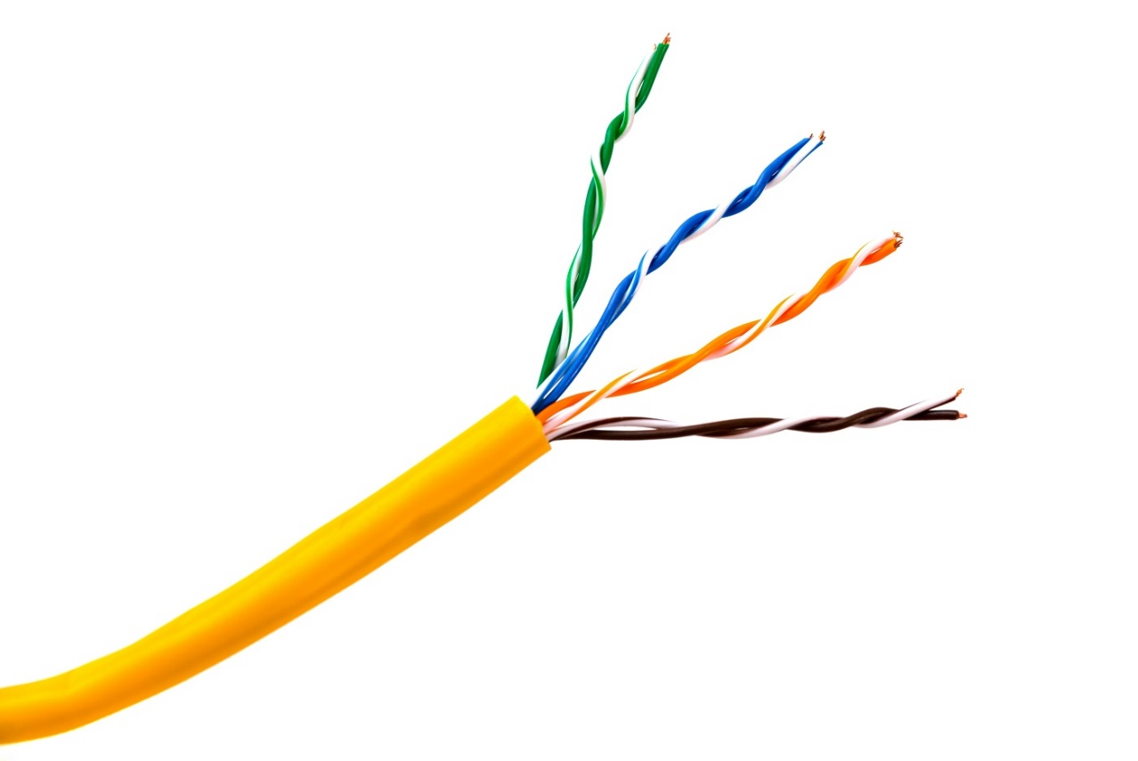

* + Working Principle: Twisted wire is a type of guided media that consists of two insulated copper wires twisted together in a helical form. The twisting helps reduce electromagnetic interference and crosstalk between adjacent pairs of wires.
  + Range: Twisted wire can support data transmission rates up to several Mbps for short distances, typically up to a few kilometers.
  + Applications: Twisted wire is commonly used in telephone systems, local area networks (LANs), and some broadband connections.
  + Advantages:
    - Cost-effective and easy to install.
    - Suitable for short-distance communication needs.
    - Provides reasonable data transmission rates for basic applications.
  + Disadvantages:
    - Prone to electromagnetic interference and noise, affecting data quality.
    - Limited bandwidth and distance compared to other guided media.

1. **Shielded Twisted Pair (STP**):

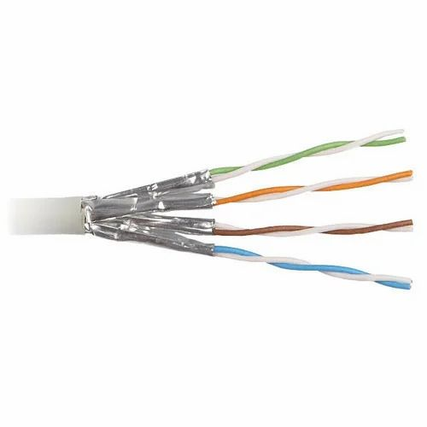

* + Working Principle: STP is a variation of twisted wire with additional shielding (usually metallic foil or braided mesh) around each twisted pair, providing better protection against external interference.
  + Range: STP offers improved performance and can support higher data rates compared to unshielded twisted pair (UTP).
  + Applications: STP is used in environments with higher electromagnetic interference, such as industrial settings and data centers.
  + Advantages:
    - Improved protection against external interference.
    - Higher data transmission rates and longer distance capabilities compared to UTP.
  + Disadvantages:
    - More expensive and bulkier than UTP.
    - Installation and maintenance can be more complex.

1. 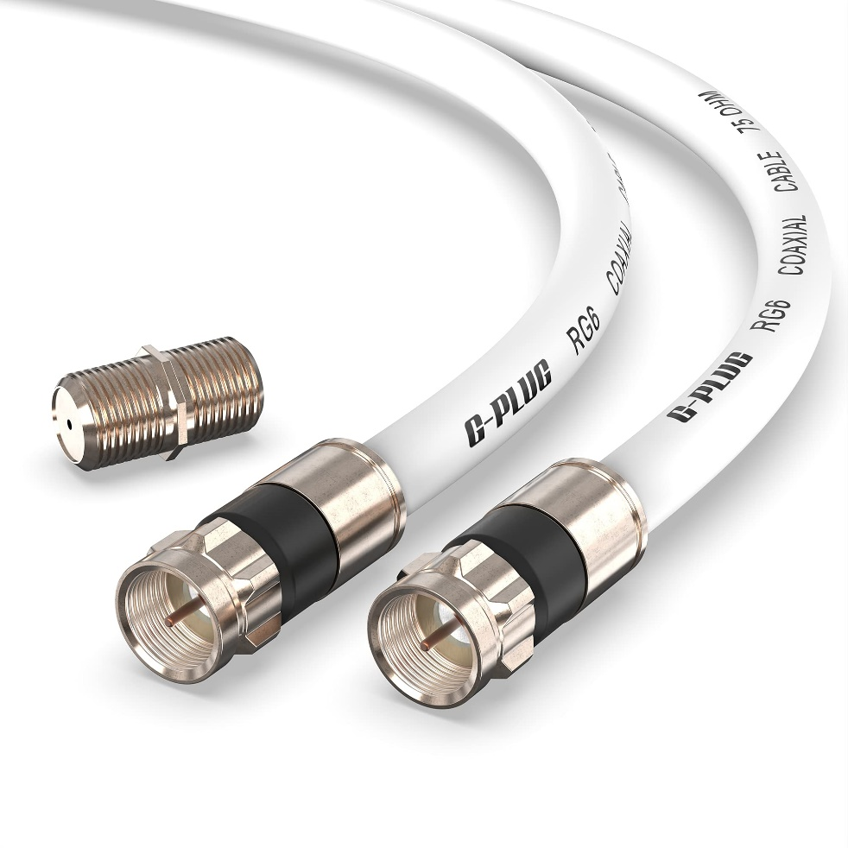**Coaxial Cable**:
   * Working Principle: Coaxial cable consists of a copper conductor at the center, surrounded by a dielectric insulating layer, and an outer metallic shield. The shield helps prevent signal loss due to external interference.
   * Range: Coaxial cables can support data transmission rates up to several Gbps over relatively long distances, typically up to 10 kilometers or more.
   * Applications: Coaxial cables are used in cable television (CATV) networks, broadband internet, and CCTV systems.
   * Advantages:
     + High data transmission rates and longer reach compared to twisted pair cables.
     + Less susceptible to electromagnetic interference.
   * Disadvantages:
     + Thicker and less flexible than twisted pair cables.
     + Costlier and more challenging to install.
2. **Optical Fibe**r:  
   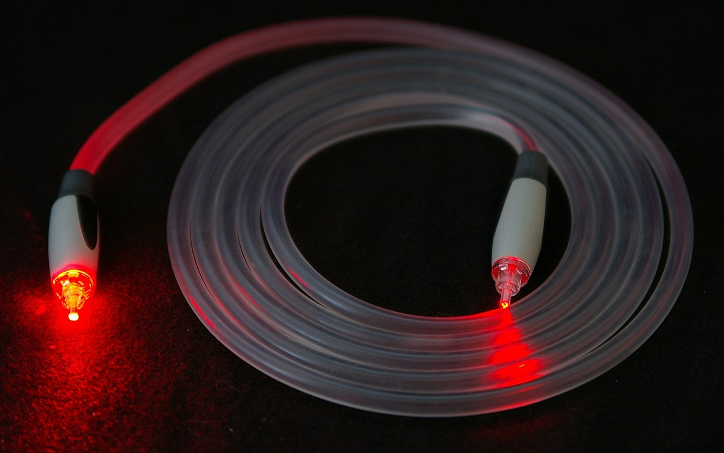
   * Working Principle: Optical fiber uses thin strands of glass or plastic (fiber) to transmit data as pulses of light, utilizing the principle of total internal reflection.
   * Range: Optical fiber offers very high data transmission rates, ranging from Mbps to Tbps, and can cover long distances, spanning hundreds of kilometers without significant signal loss.
   * Applications: Optical fiber is extensively used in long-distance telecommunication networks, high-speed internet connections, and high-bandwidth data transmission.
   * Advantages:
     + Immunity to electromagnetic interference, making it ideal for high-noise environments.
     + Extremely high data transmission rates and long-distance capabilities.
     + Lighter and more durable than copper-based cables.
   * Disadvantages:
     + Higher installation and equipment costs compared to other guided media.
     + More delicate and susceptible to damage during installation and maintenance.

**Conclusion:**

In conclusion, guided media plays a vital role in the transmission of signals in wired or physically confined environments. The three main types of guided media, namely twisted wire, coaxial cable, and optical fiber, each offer unique advantages and disadvantages. Twisted wire is a cost-effective option suitable for short-distance communication needs but is prone to electromagnetic interference. Shielded twisted pair (STP) provides improved protection against external interference, making it preferable for industrial settings and data centers. Coaxial cable offers high data transmission rates and is less susceptible to electromagnetic interference, making it a popular choice for cable television networks and broadband internet. On the other hand, optical fiber excels in providing extremely high data transmission rates and immunity to electromagnetic interference, making it the preferred choice for long-distance telecommunication networks and high-bandwidth data transmission. While each guided medium has its strengths and limitations, the selection of the appropriate medium depends on specific requirements, data transmission needs, distance, and budget considerations.

Top of Form